**World War I**

Also known as the Great War, World War I was a global conflict that lasted from July 1914 to November 1918. The event that sparked it, the assassination of Archduke Franz Ferdinand (1863-1914) in Sarajevo on June 28, 1914, was merely the catalyst that intensified the simmering tensions between Austro-Hungary and Serbia; Germany and the Francophone countries (France, Belgium, Luxembourg); and Russia and Germany. The resulting cataclysm, one of the largest and most destructive conflicts in history – the ‘war to end all wars’, as it was mistakenly called – was a determinedly modern event, hence situated on the same historical plane as the various movements identifiable as modernist. The war’s modernity can be seen, first, in terms of its scale. It was the first truly globalwar, involving all the major powers fighting within and/or beyond their immediate regions, in many instances through their colonies. Second, advancements in the technology of reporting meant that the horrific details of the war could, via telephones and wireless communication, be transmitted rapidly across continents; the enormous losses suffered by both sides became public knowledge, precipitating a Europe-wide loss of innocence. And third, it was a resolutely technological struggle, involving mechanized warfare on the ground (tanks), under the sea (U-boats) and in the air (zeppelins, fighter aircraft, strategic bombers and, towards the end, aircraft carriers).

Modernist responses to the war’s seismic effects are not easily demarcated, reaching across disciplinary boundaries and resisting cogent analysis. Nevertheless, their outlines can be tracked using three rubrics: modernist attitudes to the war, while it was taking place; works produced in the war’s aftermath, that register its profound impact on modernist culture; and autobiographical accounts by modernist writers, produced in retrospect. There is, in addition, a more speculative aspect of the relationship between modernism and the war. Put simply, there was significant modernist activity before the First World War. With this in mind, and in order to define more fully the interaction between the two, it is necessary to sketch out some of the ways in which early modernism anticipates the destructive energies unleashed by the war.

**Pre-War Auguries**

Nineteenth-century writers, thinkers and social planners put great stock in one all-purpose narrative: that civilization connoted progress, and that the human race was perfectible. Even writers who explored social discontent and class conflict clung instinctively to this belief. For Joseph Conrad, however, who had witnessed imperial misadventure first-hand, as a seaman in the Merchant Navy between 1878 and 1894, this ideology was indefensible. His 1901 novella, *Heart of Darkness*, sets the tone for English-language literary modernism, with its bleak, often despairing diagnosis of Western values. Civilisation is but the other side of the coin of barbarism; scratch at the surface of Western triumphalism, says Conrad, and the façade will quickly crumble. The war, with large-scale mechanized slaughter a routine occurrence, seemed a dire confirmation of this disquieting vision.

Other modernists were more in step with the war as a cataclysmic event of modernity. F. T. Marinetti, the founder of and spokesman of Italian Futurism – a movement that encompassed writing, painting, architecture and music – sought to glorify war, defining it in his 1909 manifesto as ‘the world’s only hygiene’. His rhetoric of violence and destruction, directed against all forms of authority, bureaucracy and tradition, found ominous fulfillment when war broke out five years later. Marinetti also spurred English modernism to similar declamations of belligerence. His visits to London in the early 1910s drew large crowds, prompting Ezra Pound and Wyndham Lewis to launch a counter-offensive, in the guise of their Vorticist movement – a strategically provocative attack on bourgeois pieties and mainstream aesthetic tastes. The flagship Vorticist publication, *Blast* (http://bit.ly/OAfirj), appeared the month before Britain joined the Allied war effort.

Back across the Channel, German Expressionism established itself in 1910 as a counter-realist movement in painting, poetry and drama. Its proponents were drawn to the morbid underside of metropolitan life, in which basic human activities are treated as commodity forms (particularly sex, i.e., prostitution) and cruelty and alienation are ubiquitous. Again, the real-life nightmares that were to take place on the Western Front, a few short years later, appeared to confirm the Expressionists’ deepest concerns about modern existence.

**Modernist** **Outlooks: 1914-18**

Once the war was underway, modernist attitudes to it ran the whole gamut. At one end of the spectrum was the Bloomsbury group: broadly anti-war, they espoused philosophical pacifism as a basic ethical principle. The principle was tested by Lytton Strachey (1880-1932) – the critic, biographer and unofficial spokesman for Bloomsbury – who, when forced to justify himself to a military tribunal, asked to be treated as a conscientious objector. The art critic Clive Bell (1881-1964) also drew opprobrium when he published a short polemic in 1915, *Peace at Once*, in which he argued for a negotiated settlement to the war; the Lord Mayor of London confiscated the pamphlet in 1916. The same year Bell’s intellectual confrere, novelist E. M. Forster, faced conscription. To avoid military service he declared himself to be a pacifist ‘by instinct’, in keeping with Bloomsbury’s wider humanitarian ethos.

At the other end of the spectrum, a number of prominent modernist writers and painters fearlessly enlisted. Enthusiasm for the war was, not surprisingly, most intense in the Futurist camp. Many volunteered for duty, when Italy entered the war in 1915; Marinetti claimed that thirteen of them died, including Umberto Boccioni (1882-1916), his manifesto collaborator and the movement’s main theorist. Whilst fighting in the French army, the Vorticist sculptor and painter Henri Gaudier-Brzeska (1891-1915) asserted (in a piece written from the trenches), ‘This war is a great remedy’ (http://bit.ly/Mxl4py); he died in combat soon after, in June 1915. The English critic and poet T. E. Hulme (1883-1917), a colleague of Gaudier-Brzeska’s, felt just as strongly about the war, and believed it to be necessary; in one of the ‘War Notes’ he produced for *The New Age* (vol 18 [1-18] http://bit.ly/fHg7Dn), he excoriated Clive Bell for his pacifism and cowardice. Hulme volunteered as an artilleryman in 1914 and, during his first tour of duty in France, composed a ‘Diary from the Trenches’ – a stark and unforgiving account of trench warfare, describing days of profound, anxiety-ridden boredom punctuated by hours of mind-wrenching terror. Hulme was wounded in 1916 and sent back to England, only to die the following year in Flanders, from a direct hit by a shell.

Other modernists, who both fought in and survived the war, made aesthetic use of the experience. The writer Ford Madox Ford (when he was still known as Ford Madox Hueffer) served as a lieutenant in the Welch Regiment. During the Battle of the Somme in 1916 Ford suffered shell-shock, and in 1917 he was invalided back to England. In letters to his erstwhile collaborator, Joseph Conrad, Ford – who had first-hand knowledge of what enemy artillery could do – gave impressionist accounts of what he had seen and heard. For example, he noted that during an electrical storm a nearby howitzer sounded like stage thunder, and the noise of shells falling on a church was likened to crockery falling off a tray. Ford’s war experiences also inspired some of his poetry, having already elucidated the war’s bloodshed and misery in the 1915 poem ‘Antwerp’. In contrast to nearly all of the above, Wyndham Lewis seems to have survived the war relatively unscathed. He volunteered in the Royal Artillery as a bombardier, or non-commissioned officer, and in 1917 was posted to the Western Front. During his time there Lewis produced several satirically inflected war stories, including the notorious ‘Cantleman’s Spring Mate’ (1917; *The Little Review* 4 (6) http://bit.ly/MXZVaJ), censored by the U. S. postmaster for ostensive ‘obscenity’. In addition, Lewis was appointed as an official war artist by both the British and Canadian governments, beginning in December 1917.

**Aftermath: The War in Modernism**

It must be acknowledged that the best-known artistic response to the war is the work produced by the Georgian War Poets, Wilfred Owen, Siegfried Sassoon and Robert Graves – all of whom fought, and all of whom questioned the virtue, if any, of patriotism and the competence of the military mind. Their tone of moral indignation and reproach is, for many, a more plausible reaction to the war’s unmitigated horror than the modernist catalogue of responses that includes detachment, impersonality, impressionistic acuity and satirical flair. A notable exception is Ezra Pound, who volunteered for military service but, as an expatriate American in England, was ineligible. However, his reflections on the war in the poem *Hugh Selwyn Mauberley* (1920) are as vehement as any disillusioned combatant’s, and contain some of his bitterest and most direct lines: soldiers who ‘walked eye-deep in hell / believing in old men’s lies’; ‘Daring as never before, wastage as never before’; and the sound of ‘laughter out of dead bellies’.

But if the war’s political aspects are largely peripheral to modernist innovation, its psychopathological ramifications are not. As Virginia Woolf demonstrated in 1925 with *Mrs Dalloway*, modernist forms are particularly apt for depicting the traumatized mind. The novel’s title character, Clarissa Dalloway, is ‘mirrored’ in oblique ways by Septimus Warren Smith, a shell-shocked World War I veteran who seeks, but is cruelly denied, adequate treatment for his condition. Woolf judiciously shows the symptoms of shell shock to have much in common with modernist narrative poetics – both involving discontinuities of memory, sudden and uncontrollable flashbacks, psychic disjunction, emotional insomnia, and the breakdown of language and identity.

Marcel Proust approaches the war somewhat differently in *Le Temps retrouvé* (*Finding Time Again*), published posthumously in 1927. His narrator adopts a number of different perspectives as he charts the effects of the war on the French social fabric. These range from opinions on patriotism and the war’s duration to detailed discussions of military strategy; the aesthetic spectacle of nocturnal air-raids over Paris; and the abiding sense of the war as some quasi-imaginary event, enigmatic and remote. The narrator’s reflections culminate in a strange, dreamlike episode that leads him to a male brothel, in which the threads of sex, death and war get tied together in a sadomasochistic knot.

**Looking Back: Modernist Memoirs**

For most of the interwar years it was believed that the fragmentary, discontinuous nature of the First World War could not be narrativised as orthodox history. This lent a certain prestige to subjective construals of the event, to which the modernist memoir added formal innovation. One of the first such accounts also became one of the most controversial: Ernst Jünger’s (1895-1998) *In Stahlgewittern* (*Storm of Steel*), published privately in 1920. Jünger joins the German army when the book opens, rises to the rank of officer, and suffers multiple wounds fighting on the Western Front. The book’s controversy stems from the morbid pleasure Jünger appears to take in the exigencies of war. He presents combat as a test, a redemptive and regenerative experience that can foster a more authentic personal identity. Though his relationship to the modernist credo is not clearly defined, Jünger has been seen as a German variation on the phenomenon of ‘fascist modernism’, fomented by F. T. Marinetti in Italy and continued by Louis-Ferdinand Céline (1894-1961) in France.

In contrast to Jünger’s apocalyptic and overwrought rhetoric, Wyndham Lewis’s *Blasting and Bombardiering* and David Jones’s (1895-1974) *In Parenthesis* (both 1937) sideline the war’s transformative potential. Lewis shows art and war to be inseparable. His hard-nosed account is simultaneously a lament for the Vorticist movement, cut short in its prime, and an acerbic reminder of war’s romantic enticements. More ambitious is Jones’s prose-poem *In Parenthesis*, as much mythological reclamation as it is memoir. Jones was an infantryman for the Royal Welch Fusiliers; like Jünger, he took part in the First Battle of the Somme in 1916, which provides the basis for his work’s climactic episode. *In Parenthesis* is composed throughout of voices, most of them unbidden and unidentified, articulating half-forgotten songs, soldiers’ chants and church hymns, and promoting allusions to Celtic myth and Arthurian legend. Almost twenty years in the making, Jones’s poetic reconstruction of soldierly life conjoins intimacy and anonymity, camaraderie and estrangement. On the eve of another global cataclysm, it was a fitting epitaph for the modernist war experience.

*Paul Sheehan, Macquarie University*

**References and further reading**

Modernist war texts

Bell, C. (1915) *Peace at Once*, Manchester and London: National Labour Press.

Conrad, J. ([1899] 1990) *Heart of Darkness and Other Tales*, Oxford: Oxford University Press.

Hulme, T. E. (1995) *Further Speculations*, ed. S. Hynes, Minneapolis: Minnesota University Press.

Jones, D. (1937), *In Parenthesis: seinnyessit e gledyf ym penn mameu*, London: Faber & Faber.

Jünger, E. (1920) *In Stahlgewittern*, trans. M. Hoffman as *Storm of Steel,* New York: Penguin, 2004.

Lewis, W. (ed.) (1914) *Blast: Review of the Great English Vortex* 1, London: John Lane, The Bodley Head.

------ (1973) *Unlucky for Pringle: Unpublished and Other Stories*, eds. C. J. Fox and R. T. Chapman, London: Vision Press.

------ (1937) *Blasting and Bombardiering,* London: Eyre & Spottiswoode.

Marinetti, F. T. (1972) *Marinetti: Selected Writings*, ed. R. W. Flint, trans. R. W. Flint and A. A. Coppotelli, London: Secker & Warburg.

Pound, E. (1977) *Selected Poems 1908-1959*, London: Faber and Faber.

Proust, M. (1927) *Le Temps Retrouvé*, trans. I. Patterson as *Finding Time Again*, London: Allen Lane, 2002.

Woolf, V. (1925) *Mrs Dalloway*, London: Hogarth Press.

Critical studies

Atkin, J. (2002) *A War of Individuals: Bloomsbury Attitudes to the Great War*, Manchester: Manchester University Press.

Carden-Coyne, A. (2009) *Reconstructing the Body: Classicism, Modernism, and the First World War*, Oxford and New York: Oxford University Press.

Cole, S. (2003) *Modernism, Male Friendship, and the First World War*, Cambridge: Cambridge University Press.

Hewitt, A. (1993) *Fascist Modernism: Aesthetics, Politics, and the Avant-Garde*, Stanford: Stanford University Press.

Sherry, V. (2004) *The Great War and the Language of Modernism*, Oxford: Oxford University Press.

Smith, A. K. (2010) *The Second Battlefield: Women, Modernism and the First World War*. Manchester: Manchester University Press.

Walsh, M. J. K. (ed.) (2010) *London, Modernism, and 1914*, Cambridge and New York: Cambridge University Press.

Tate, T. (1998) *Modernism, History and the First World War*, Manchester: Manchester University Press.

**Paratextual Material**

(1) Lewis, W. (ed) (1914) *Blast* 1 <<http://bit.ly/OAfirj>> The Modernist Journals Project (searchable database). Brown and Tulsa Universities, ongoing. (See <http://bit.ly/p4o7vl> for copyright, permissions information.)

(2) German Expressionism (“particularly sex, i.e., prostitution”): [**attached**]

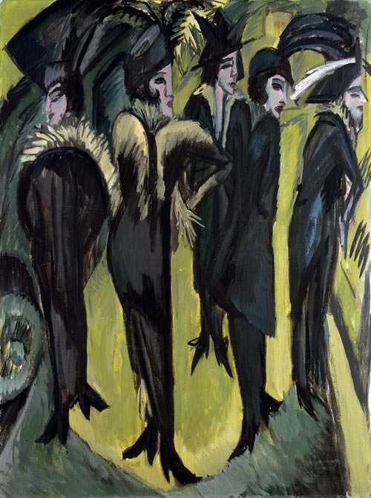

**Fig. 1** Kirchner, E. L. (1913) *Five Women on the Street*, Museum Ludwig <<http://bit.ly/Qu2hl5>>.

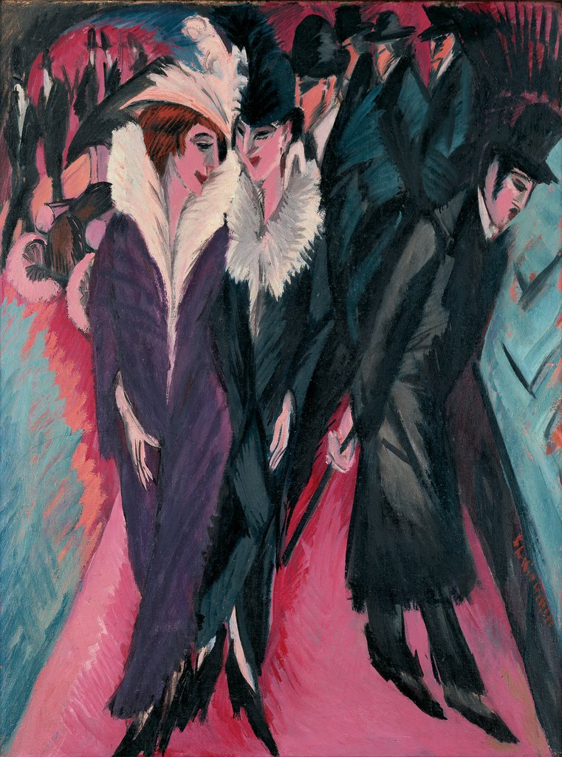

**Fig. 2** Kirchner, E. L. (1913) *Street, Berlin*, Museum of Modern Art <<http://bit.ly/penxrl>>.

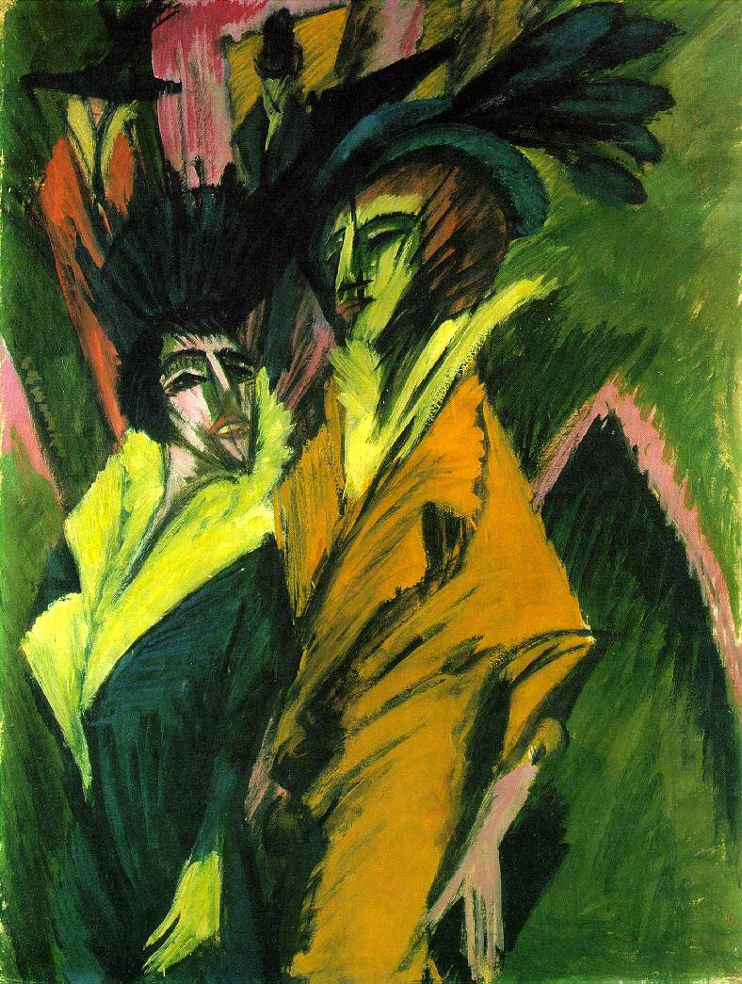

**Fig. 3** Kirchner, E. L. (1914) *Two Women in the Street*, Kunstsammlung Nordrhein-Westfale *<*http://bit.ly/MhMYKG*>*.

(3) Henri Gaudier-Brzeska (Vorticist sculptor and painter): [**attached**]

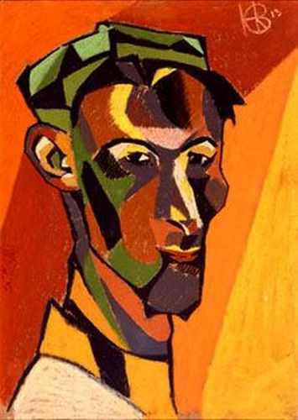

**Fig. 4** Gaudier-Brzeska, H. (1913) *Self Portrait*, Southampton City Art Gallery <http://bit.ly/Pnx8c8>.

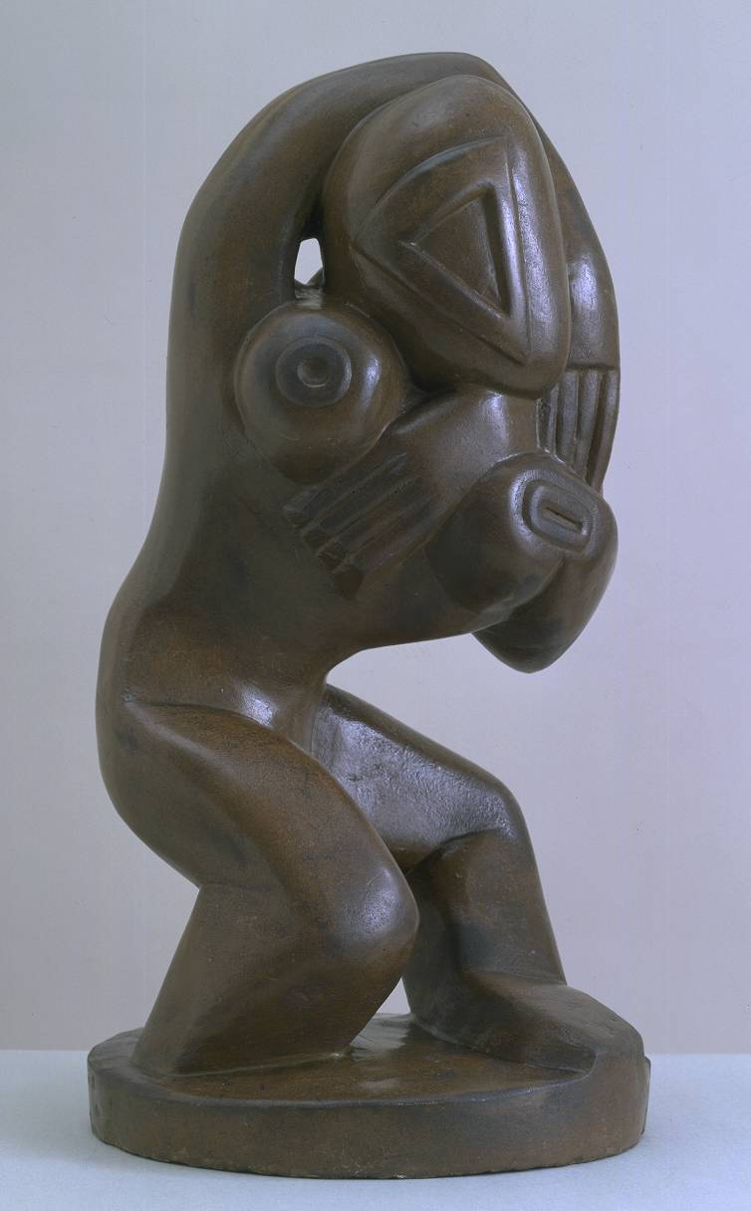

**Fig. 5** Gaudier-Brzeska, H. (1913) *Red Stone Dancer*, Tate Britain <http://bit.ly/N9rF90>.

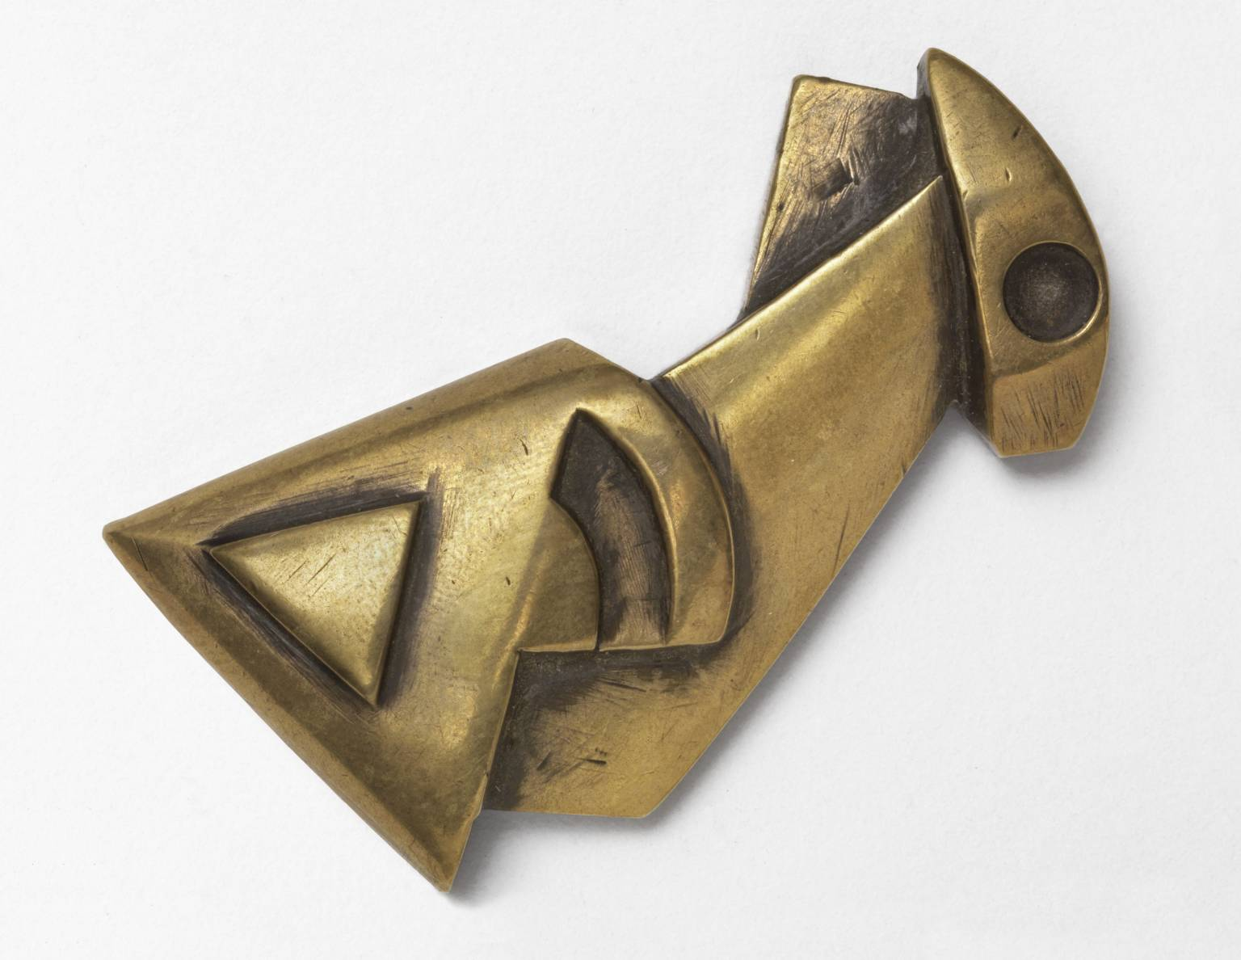

**Fig. 6** Gaudier-Brzeska, H. (1914) *Fish*, Tate Britain, <http://bit.ly/Qu551w>.

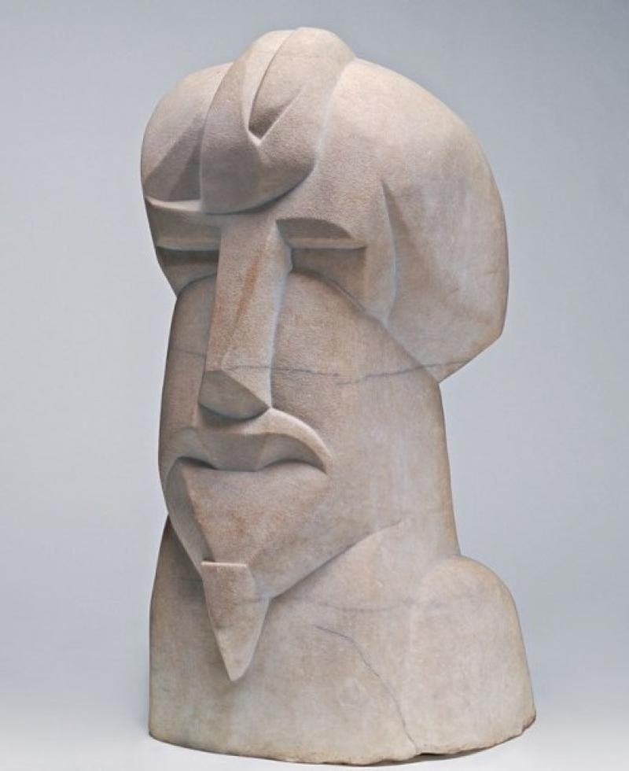

**Fig. 7** Gaudier-Brzeska, H. (1914) *Hieratic Head of Ezra Pound*, National Gallery of Art, Washington <http://bit.ly/R5Anen>.

(4) Wyndham Lewis (war art): **[attached**]

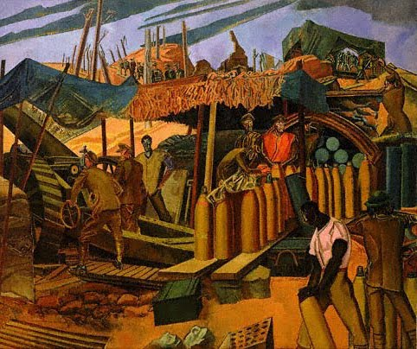

**Fig. 8** Lewis, W. (1918) *A Canadian Gun-pit*, National Gallery of Canada <http://bit.ly/NHLwBd>.

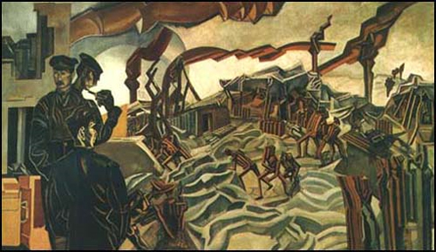

**Fig. 9** Lewis, W. (1919) *A Battery Shelled*, Imperial War Museum < http://bit.ly/IxjnG8>.